LGB Policy and the Geography of Immigrants in Same-Sex Couples in the United States

Same-sex marriage and Migration Workshop in Amsterdam

Nathan I. Hoffmann, Department of Sociology, UCLA

Kristopher Velasco, Department of Sociology, Princeton University

August 27, 2024

Abstract

How do queer immigrants decide where to settle? The policy landscape for same-sex couples in the United States has changed rapidly in recent years, with immigrants being particularly affected. After the 2013 end of the Defense of Marriage Act, U.S. citizens could finally sponsor the visa of a same-sex partner. As previous work of ours has shown, in the wake of this policy change there has been a rapid increase of immigrants in same-sex couples, at least for those from progressive countries (Hoffmann & Velasco 2024). But little is known about where these immigrants choose to settle and enjoy their new rights. Do they gravitate toward queer-friendly cities and states, or are they more concerned with job opportunities or cost of living? How have these patterns changed over time, especially in response to local policy changes relevant to queer people and immigrants? Using American Community Survey data from 2008-2022, this paper will implement descriptive analyses and conditional logit models to study how settlement patterns of immigrants in same-sex couples in the U.S. respond to local and national policy changes as well as other local factors. These geographic measures will include the Human Rights Campaign’s Municipal Equality Index, Velasco’s LGBT Policy Index for U.S. states, and a host of other local measures such as housing prices, average income, queer density, and prevalence of immigrants from the same national origins.

# Introduction

In 2013, the U.S. Supreme Court overturned the Defense of Marriage Act and required the U.S. government to begin recognizing marriages between same-sex spouses. Among many consequences, this decision radically changed the immigration landscape: For the first time, same-sex spouses of U.S. citizens and lawful permanent residents were eligible to file a spousal petition for an immigrant visa (Edwards 2013). In the years since, the U.S. population of immigrants in same-sex couples has grown rapidly (Hoffmann and Velasco 2023, 2024).

The Supreme Court ruling occurred against a backdrop of rapidly changing laws concerning same-sex couples – and LGB communities, generally – both in the U.S. and abroad. As some countries expanded rights and social recognition, others imposed new forms of repression (Hadler and Symons 2018). These varied dynamics raise an important question: How do changing policy environments influence the migration patterns of individuals in same-sex couples into and across the U.S.? Migration scholarship has begun to recognize the role of the state to shape both the aspirations and capabilities to migrate through social policies, even those unrelated to migration itself (de Haas 2021; Fitzgerald, Leblang, and Teets 2014). Moreover, while gender is increasingly recognized as an integral part of the migration process (Lutz 2010; Hondagneu-Sotelo 2012), sexuality receives relatively scant attention. Emerging qualitative work has demonstrated that both sexuality and the policies governing it are highly salient factors influencing migration decisions to the U.S. (Ahmad 2013; Carrillo 2018; Mai and King 2009; Gorman-Murray 2009). Studying the migration of same-sex couples into and across the U.S. allows us to make broader inferences into how the interaction between sexuality and policy shape migration decisions, underscoring the importance of political and “lifestyle” considerations into understandings of migration (Benson and O’Reilly 2012; Fitzgerald, Leblang, and Teets 2014).

How do queer immigrants decide where to settle? The policy landscape for same-sex couples in the United States has changed rapidly in recent years, with immigrants being particularly affected. After the 2013 end of the Defense of Marriage Act, U.S. citizens could finally sponsor the visa of a same-sex partner. As previous work of ours has shown, in the wake of this policy change there has been a rapid increase of immigrants in same-sex couples, at least for those from progressive countries (Hoffmann & Velasco 2024). But little is known about where these immigrants choose to settle and enjoy their new rights. Do they gravitate toward queer-friendly cities and states, or are they more concerned with job opportunities or cost of living? How have these patterns changed over time, especially in response to local policy changes relevant to queer people and immigrants? Using American Community Survey data from 2008-2022, this paper will implement descriptive analyses and conditional logit models to study how settlement patterns of immigrants in same-sex couples in the U.S. respond to local and national policy changes as well as other local factors. These geographic measures will include the Human Rights Campaign’s Municipal Equality Index, Velasco’s LGBT Policy Index for U.S. states, and a host of other local measures such as housing prices, average income, queer density, and prevalence of immigrants from the same national origins.

# Background

# Data and Methods

Our main source of data is the American Community Survey for 2008 to 2022 (except for 2020, when data quality was not good) (Ruggles et al. 2021). Each year, the ACS surveys a 1-percent representative sample of U.S. households about their education, occupation, income, family structure, immigration status, country of origin, location, and a variety of other individual and household attributes. We define a same-sex couple as two individuals of the same sex in the same household who report their relationship as “spouse” or “unmarried partner.” We limit the sample to individuals age 18 to 64, and immigrants in the sample migrated at the age of 18 or older.

We consider the spatial distribution of three groups: immigrants in same-sex couples, immigrants in different-sex couples, and individuals in same-sex couples where neither individual is an immigrant. The 14 years of survey data contain XX cases.

We use “LGB” to refer to all individuals who may be in romantic relationships with members of the same sex, although we recognize that some individuals in same-sex relationships may not identify as lesbian, gay, or bisexual. We also recognize that we are not able to identify bisexual (or pansexual, multisexual, etc.) individuals cohabiting with different-sex partners. Furthermore, measuring the prevalence of same-sex couples in the U.S. is difficult (Michaels 2013). As in most nationally representative demographic work on same-sex couples (Baumle 2013; Baumle and Dreon 2019), we are able to identify only LGB couples that cohabit; unpartnered LGB individuals and those who do not live with their partner are not included in the analysis (Baumle, Compton, and Poston 2009, 6). In addition, LGB individuals who do not feel comfortable with the partner labels of the ACS are not in the sample. Another pitfall is measurement error: Misreporting may result when different-sex couples accidentally misspecify the gender of one of the partners (Gates and Steinberger 2009; Goodnature and Neto 2021). Beginning in 2008, the Census Bureau made changes to ACS gender and partnership questions in order to prevent such errors (U.S. Census Bureau 2013), so we rely on data only from 2008 onward, but difficulties remain. If even a small number of different-sex couples misreport one partner’s sex, the counts of same-sex couples will be inflated. Following Gates and Steinberger (2009), we remove all respondents that had either their relationship or sex variable allocated by the Census Bureau, which results in dropping XX immigrants in same-sex couples and XX in different-sex couples, or XX percent of the sample. This is the strategy used by most studies of same-sex couples in the ACS (e.g. Boertien and Vignoli 2019; Gates 2013; Goldberg and Conron 2021; Christafore and Leguizamon 2019; Martell and Nash 2020). In Section C of the Online Appendix we include robustness checks to test the sensitivity of our results to hypothetically high rates of misreporting.

## Analytic Strategy

Many of our analyses entail descriptive statistics of ACS data. For these and for the reshaping described below, we apply survey weights from the ACS.

One of our goals is to isolate the effect of country-of-origin LGB policy on the immigration of immigrants in same-sex couples. The ideal survey would follow potential immigrants over time and have information about sexual orientation, allowing us to estimate how the probability of migrating and choice of U.S. state of residence vary by sexual orientation. This ideal dataset does not exist, but we attempt to approximate it.

We reshape the data so that each observation is the percentage of individual cohabiting immigrants in same-sex couples from country $x$ in state $y$ in survey year $z$

## Variables

Most of our variables come from the ACS and are calculated at the level of the Public Use Microdata Area (PUMA), a unit of analysis that includes at least 100,000.

We also use data from two other sources. First, to examine LGB policies at state of destination, we use original datasets. To create the U.S. state policy index, we compile data from the Movement Advancement Project[1], a leading LGB organization in the U.S. that collects data on a number of relevant policies. Our state index encompasses both progressive policies (full marriage equality, state recognition of civil unions and domestic partnerships, ban on all employment and housing discrimination based on sexual orientation, hate crime protections based on sexual orientation, legal joint adoption by same-sex couples, and a ban on conversation therapy for minors) and regressive policies (criminalization of sodomy, state constitutional bans of marriage equality, religious freedom exemptions to discriminate against same-sex couples in adoption, and state-level bans on local non-discrimination ordinances encompassing sexual orientation). The state index ranges from X to X, and the mean state policy score for immigrants in our sample is X.

Our second outside data source is a measure of the prevalence of LGBT nonprofits in a given PUMA. These come from complete IRS data on nonprofits.

# Results

# Discussion and Conclusion

# References

Ahmad, Ali Nobil. 2013. “Sexuality and Migration: Thinking Beyond the Economic.” In *Masculinity, Sexuality and Illegal Migration: Human Smuggling from Pakistan to Europe*, 67–93. Ashgate Publishing, Ltd.

Baumle, Amanda K., ed. 2013. *International Handbook on the Demography of Sexuality*. Vol. 5. International Handbooks of Population. Dordrecht: Springer Netherlands. <https://doi.org/10.1007/978-94-007-5512-3>.

Baumle, Amanda K., D’Lane Compton, and Dudley L. Poston. 2009. *Same-Sex Partners: The Social Demography of Sexual Orientation*. SUNY Press.

Baumle, Amanda K., and Ben Dreon. 2019. “The Demography of Sexuality.” In *Handbook of Population*, edited by Dudley L. Poston Jr., 279–88. Handbooks of Sociology and Social Research. Cham: Springer International Publishing. <https://doi.org/10.1007/978-3-030-10910-3_11>.

Benson, Michaela, and Karen O’Reilly. 2012. *Lifestyle Migration: Expectations, Aspirations and Experiences*. Furnham, United Kingdom: Ashgate Publishing.

Boertien, Diederik, and Daniele Vignoli. 2019. “Legalizing Same-Sex Marriage Matters for the Subjective Well-Being of Individuals in Same-Sex Unions.” *Demography* 56 (6): 2109–21.

Carrillo, Héctor. 2018. *Pathways of Desire: The Sexual Migration of Mexican Gay Men*. University of Chicago Press.

Christafore, David, and Susane Leguizamon. 2019. “Taste-Based Discrimination, Tolerance and the Wage Gap: When Does Economic Freedom Help Gay Men?” *Kyklos : Jahrbuch Des Instituts für Geschichte Der Medizin an Der Universität Leipzig* 72 (3): 426–45. <https://doi.org/10.1111/kykl.12206>.

de Haas, Hein. 2021. “A Theory of Migration: The Aspirations-Capabilities Framework.” *Comparative Migration Studies* 9 (1): 8. <https://doi.org/10.1186/s40878-020-00210-4>.

Edwards, Benjamin P. 2013. “Welcoming a Post-DOMA World: Same-Sex Spousal Petitions and Other Post-Windsor Immigration Implications.” *Family Law Quarterly* 47 (2): 173–89.

Fitzgerald, Jennifer, David Leblang, and Jessica C. Teets. 2014. “Defying the Law of Gravity: The Political Economy of International Migration.” *World Politics* 66 (3): 406–45. <https://doi.org/10.1017/S0043887114000112>.

Gates, Gary J. 2013. “LGBT Adult Immigrants in the United States.” UCLA: The Williams Institute.

Gates, Gary J., and Michael D. Steinberger. 2009. “Same-Sex Unmarried Partner Couples in the American Community Survey: The Role of Misreporting, Miscoding and Misallocation.” In *Annual Meetings of the Population Association of America, Detroit, MI*.

Goldberg, Shoshana K., and Kerith J. Conron. 2021. “LGBT Adult Immigrants in the United States.” UCLA: The Williams Institute.

Goodnature, Mia, and Amir B. Ferreira Neto. 2021. “Same-Sex Unmarried Partners in the Census.” *Journal of Regional Analysis & Policy* 51 (1): 43–66.

Gorman-Murray, Andrew. 2009. “Intimate Mobilities: Emotional Embodiment and Queer Migration.” *Social & Cultural Geography* 10 (4): 441–60. <https://doi.org/10.1080/14649360902853262>.

Hadler, Markus, and Jonathan Symons. 2018. “World Society Divided: Divergent Trends in State Responses to Sexual Minorities and Their Reflection in Public Attitudes.” *Social Forces* 96 (4): 1721–56.

Hoffmann, Nathan I., and Kristopher Velasco. 2023. “Sexuality, Migration, and LGB Policy: A Portrait of Immigrants in Same-Sex Couples in the United States.” *International Migration Review*, August, 01979183231187623. <https://doi.org/10.1177/01979183231187623>.

———. 2024. “Policy Effects on Mixed-Citizenship, Same-Sex Unions: A Triple-Difference Analysis.” *Social Forces* 102 (3): 1134–56. <https://doi.org/10.1093/sf/soad108>.

Hondagneu-Sotelo, Pierrette. 2012. “New Directions in Gender and Immigration Research.” In *Routledge International Handbook of Migration Studies*. Routledge. <https://doi.org/10.4324/9780203863299.ch15>.

Lutz, Helma. 2010. “Gender in the Migratory Process.” *Journal of Ethnic and Migration Studies* 36 (10): 1647–63. <https://doi.org/10.1080/1369183X.2010.489373>.

Mai, Nicola, and Russell King. 2009. “Love, Sexuality and Migration: Mapping the Issue(s).” *Mobilities* 4 (3): 295–307. <https://doi.org/10.1080/17450100903195318>.

Martell, Michael E., and Peyton Nash. 2020. “For Love and Money? Earnings and Marriage Among Same-Sex Couples.” *Journal of Labor Research* 41 (3): 260–94. <https://doi.org/10.1007/s12122-020-09305-4>.

Michaels, Stuart. 2013. “Sexual Behavior and Practices: Data and Measurement.” In *International Handbook on the Demography of Sexuality*, 11–20. Springer.

Ruggles, Steven, Sarah Flood, Sophia Foster, Ronald Goeken, Jose Pacas, Megan Schouweiler, and Matthew Sobek. 2021. “IPUMS USA: Version 11.0 American Community Survey 2008-2019.” Minneapolis, MN: IPUMS.

U.S. Census Bureau. 2013. “Frequently Asked Questions About Same-Sex Couple Households.” U.S. Census Bureau Fertility and Family Statistics Branch.

# Tables

Table 1: Mean values for geographic variables for immigrants in different- or same-sex couples, 2008-2022

| variable | Different-sex, immigrant | Same-sex, immigrant | Same-sex, non-immigrant |
| --- | --- | --- | --- |
| Bachelor's degree (%) | 22.7 | 25.4 | 23.5 |
| Black (%) | 12.6 | 12.9 | 12.7 |
| Hispanic (%) | 24.5 | 23.6 | 16.6 |
| Mean personal income | 27.5 | 29.5 | 27.9 |
| Individuals own home (%) | 61.2 | 58.6 | 62.8 |
| Mean age | 37.7 | 38.4 | 38.5 |
| Immigrant (%) | 20.4 | 20.0 | 13.5 |
| Individuals under 100% of poverty line (%) | 12.6 | 12.4 | 12.2 |
| Individuals under 200% of poverty line (%) | 29.8 | 28.8 | 28.6 |
| Mean HWSEI occupation score | 37.0 | 37.7 | 37.3 |
| Unemployed (%) | 2.6 | 2.5 | 2.4 |
| Mean individual's value of home ($1000s) | 4,111.5 | 4,398.7 | 3,938.4 |
| Mean individual's rent | 406.6 | 481.7 | 363.8 |
| Mean cost of electricity | 2,181.3 | 2,237.4 | 2,200.9 |
| Density (persons per sq. mile) | 8,144.2 | 11,628.1 | 6,088.9 |
| pctmetro | 96.2 | 95.7 | 90.1 |
| Number of LGBT nonprofits | 1.5 | 3.6 | 2.9 |

Table 2: Proportion of immigrants in same-sex couples by PUMA, regressed on PUMA-level factors

|  |  |  |  |
| --- | --- | --- | --- |
|  | (1) | (2) | (3) |
| Bachelor's degree (%) | 0.008 | 0.043 * | 0.043 * |
|  | (0.006) | (0.020) | (0.019) |
| Black (%) | 0.009 *** | 0.010 *** | 0.010 *** |
|  | (0.001) | (0.003) | (0.003) |
| Hispanic (%) | 0.013 *** | 0.013 *** | 0.013 *** |
|  | (0.001) | (0.003) | (0.003) |
| Log mean personal income | -0.047 | 0.028 | -0.008 |
|  | (0.160) | (0.337) | (0.331) |
| Individuals own home (%) | 0.009 | -0.052 † | -0.050 † |
|  | (0.015) | (0.028) | (0.026) |
| Mean age | 0.083 *** | 0.045 | 0.047 |
|  | (0.006) | (0.032) | (0.030) |
| Immigrant (%) | -0.022 *** | -0.031 *** | -0.031 *** |
|  | (0.002) | (0.004) | (0.004) |
| Individuals under 100% of poverty line (%) | 0.003 | 0.009 | 0.009 |
|  | (0.005) | (0.009) | (0.009) |
| Mean HWSEI occupation score | 0.036 * | -0.027 | -0.026 |
|  | (0.014) | (0.041) | (0.039) |
| Unemployed (%) | 0.071 *** | 0.036 | 0.031 |
|  | (0.013) | (0.031) | (0.034) |
| Mean individual's value of home ($1000s) | 0.000 | -0.000 | -0.000 |
|  | (0.000) | (0.000) | (0.000) |
| Mean individual's rent | 0.000 | -0.000 | -0.000 |
|  | (0.000) | (0.001) | (0.001) |
| Mean cost of electricity | -0.000 *** | -0.000 | -0.000 |
|  | (0.000) | (0.000) | (0.000) |
| Density (persons per sq. mile) | 0.000 *** | 0.000 | 0.000 |
|  | (0.000) | (0.000) | (0.000) |
| State LGB policy score | 0.022 *** | -0.007 | 0.008 |
|  | (0.006) | (0.015) | (0.011) |
| Number of LGBT nonprofits | 0.179 *** | 0.171 *** | 0.171 *** |
|  | (0.005) | (0.044) | (0.046) |
| State FEs and clustered errors? | no | yes | yes |
| Year FEs and clustered errors? | no | no | yes |
| Observations | 57390 | 57390 | 57390 |
| *** p < 0.001; ** p < 0.01; * p < 0.05; † p < 0.1. | | | |

Table 3: Proportion of same-sex partnered people who are immigrants by PUMA, regressed on PUMA-level factors

|  |  |  |  |
| --- | --- | --- | --- |
|  | (1) | (2) | (3) |
| Bachelor's degree (%) | -0.361 *** | -0.140 | -0.138 * |
|  | (0.038) | (0.074) | (0.070) |
| Black (%) | 0.062 *** | 0.036 | 0.038 |
|  | (0.008) | (0.023) | (0.023) |
| Hispanic (%) | 0.087 *** | 0.076 | 0.078 |
|  | (0.009) | (0.043) | (0.045) |
| Log mean personal income | -3.466 ** | -7.251 * | -7.466 * |
|  | (1.091) | (2.924) | (3.055) |
| Individuals own home (%) | 0.047 | 0.192 | 0.206 |
|  | (0.098) | (0.265) | (0.256) |
| Mean age | 0.608 *** | 0.271 | 0.281 |
|  | (0.043) | (0.224) | (0.218) |
| Immigrant (%) | 0.525 *** | 0.392 *** | 0.388 *** |
|  | (0.013) | (0.088) | (0.082) |
| Individuals under 100% of poverty line (%) | -0.157 *** | -0.112 * | -0.112 ** |
|  | (0.034) | (0.051) | (0.036) |
| Mean HWSEI occupation score | 1.107 *** | 0.804 * | 0.804 * |
|  | (0.097) | (0.408) | (0.390) |
| Unemployed (%) | -0.005 | -0.441 *** | -0.472 *** |
|  | (0.090) | (0.077) | (0.072) |
| Mean individual's value of home ($1000s) | 0.000 | 0.002 | 0.002 |
|  | (0.001) | (0.002) | (0.002) |
| Mean individual's rent | -0.003 ** | -0.003 | -0.003 |
|  | (0.001) | (0.002) | (0.002) |
| Mean cost of electricity | -0.002 *** | -0.001 | -0.001 |
|  | (0.000) | (0.001) | (0.001) |
| Density (persons per sq. mile) | 0.000 *** | 0.000 *** | 0.000 *** |
|  | (0.000) | (0.000) | (0.000) |
| State LGB policy score | 0.428 *** | -0.167 | -0.077 |
|  | (0.039) | (0.172) | (0.147) |
| Number of LGBT nonprofits | -0.135 *** | -0.171 * | -0.174 * |
|  | (0.034) | (0.080) | (0.077) |
| State FEs and clustered errors? | no | yes | yes |
| Year FEs and clustered errors? | no | no | yes |
| Observations | 53891 | 53891 | 53891 |
| *** p < 0.001; ** p < 0.01; * p < 0.05. | | | |

# Figures



Figure 1: Geographic characteristics (percentages) over time for immigrants in different- and same-sex couples, based on American Community Survey data for 2008-2022



Figure 2: Geographic characteristics (means) over time for immigrants in different- and same-sex couples, based on American Community Survey data for 2008-2022

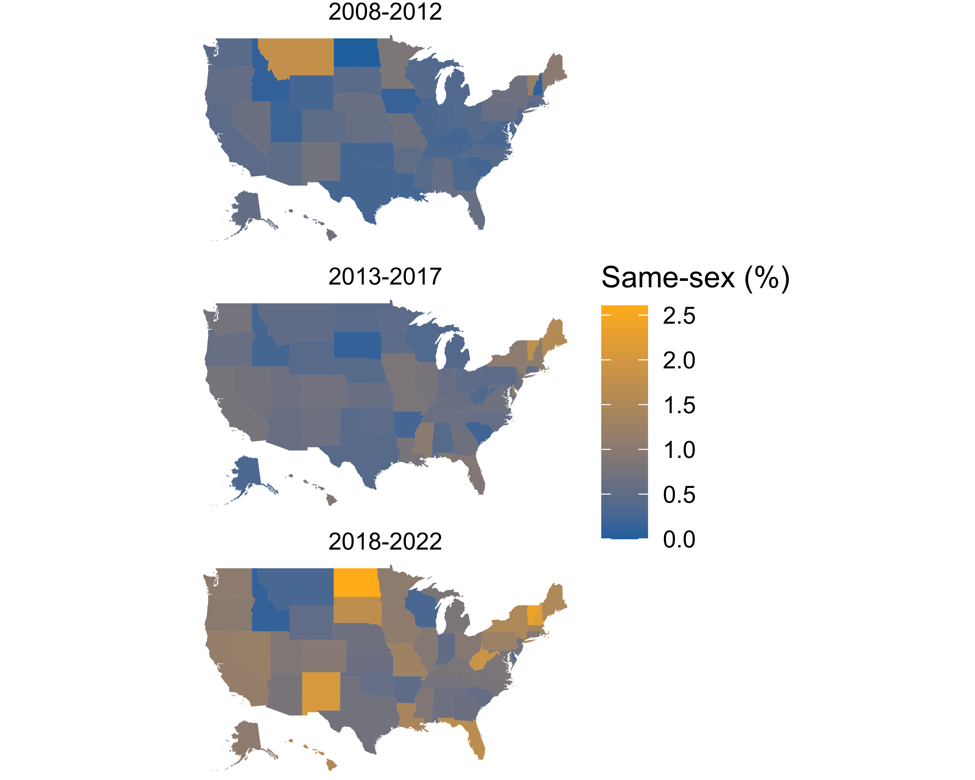

Figure 3: Percentage of cohabiting immigrants in same-sex couples in U.S. states, averaging over ACS survey years 2008 to 2022.

1. <https://www.lgbtmap.org/>